Johnny Huynh - Mod 1 Report (1/26/2021)

HTML: <http://studentweb.kennesaw.edu/~jhuynh9/>

For my HTML Site, I had created a couple of more html in order to make it easier to spread out information through the usage of tabs I made. I’ve actually started this site back in 2019 if I recall correctly though I didn’t have the time and to put more into it until given this assignment. The front home page has a slide show of images with me though with a spinning cat at the bottom middle of the page, which I intended as a filler/testing but I thought it would be fun to keep the cat there. I would use it again in About Me once more for fun. In the About Me Tab, I decided here I’ll provide as much information about myself while also providing link to various stuff such as music, a school program, and videos of past projects. Works page is self-explanatory to show off works I’ve done with groups or on my own. I currently will have two boxes with links to access the games made in both Game Jams I participated in. I hope to add more to show off the sprites and others items I’ve made for both Jams and in my free time. Contact is simple and more so as a way to test something out with html. I’ll provide screenshots below, do note that I used Google Chrome as I’ve tested the site with Microsoft Edge and does have some minor issues in design.

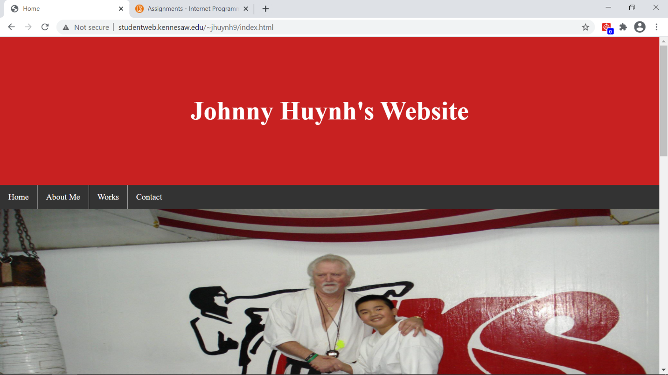

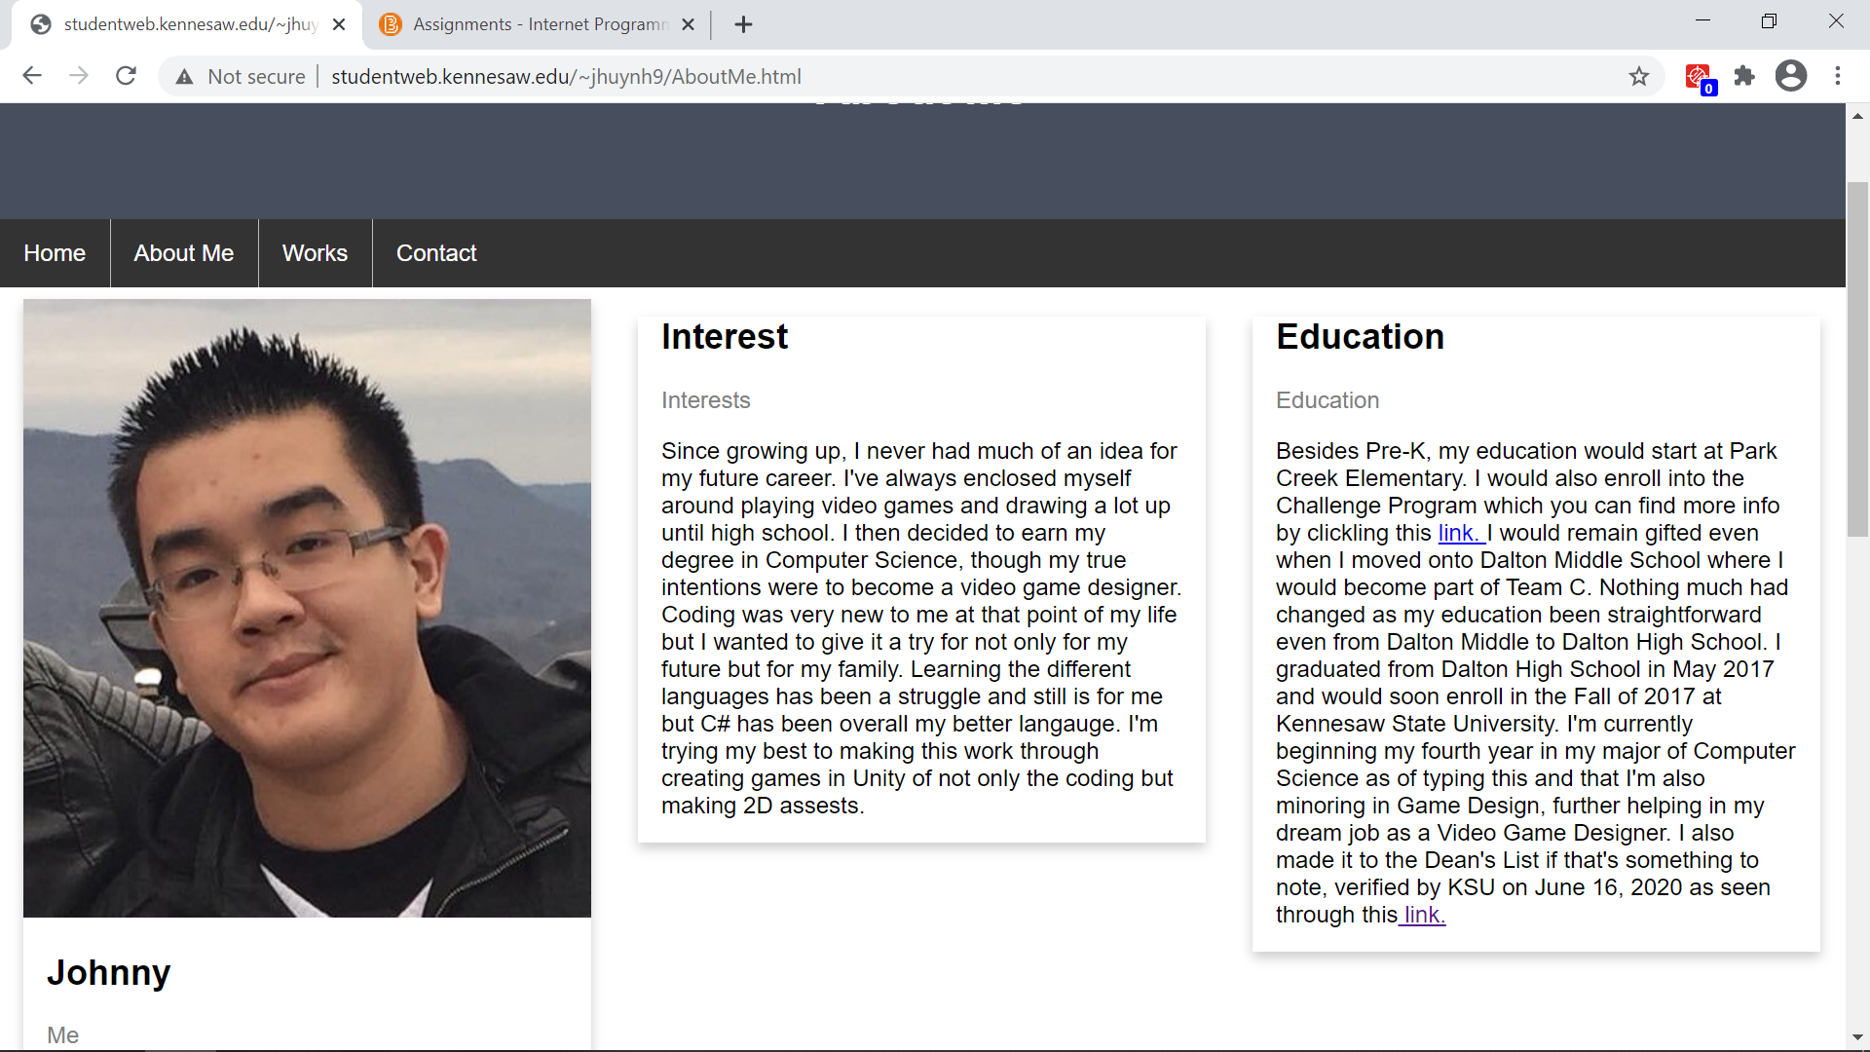

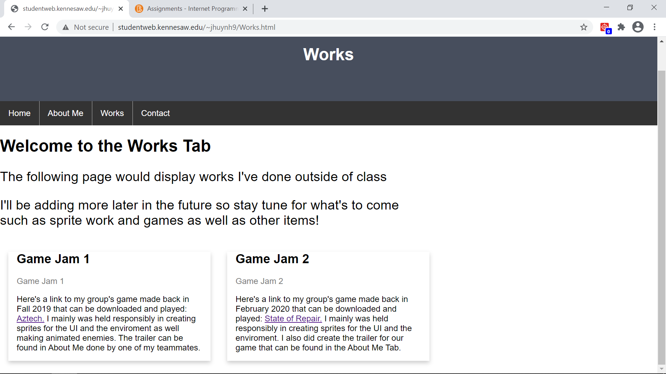

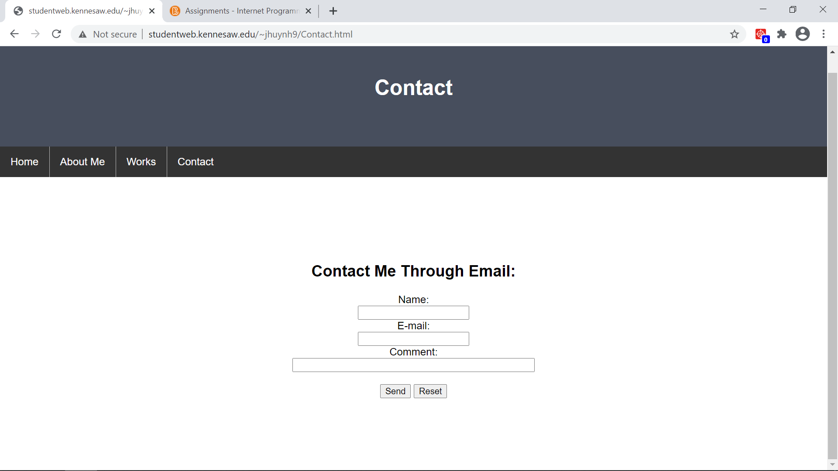

Python:

It’s actually the first time I’m using Python so it’s going to be a learning experience for me throughout this course but as of the first assignment, it’s not as bad in printing out lines as I’ll show below:

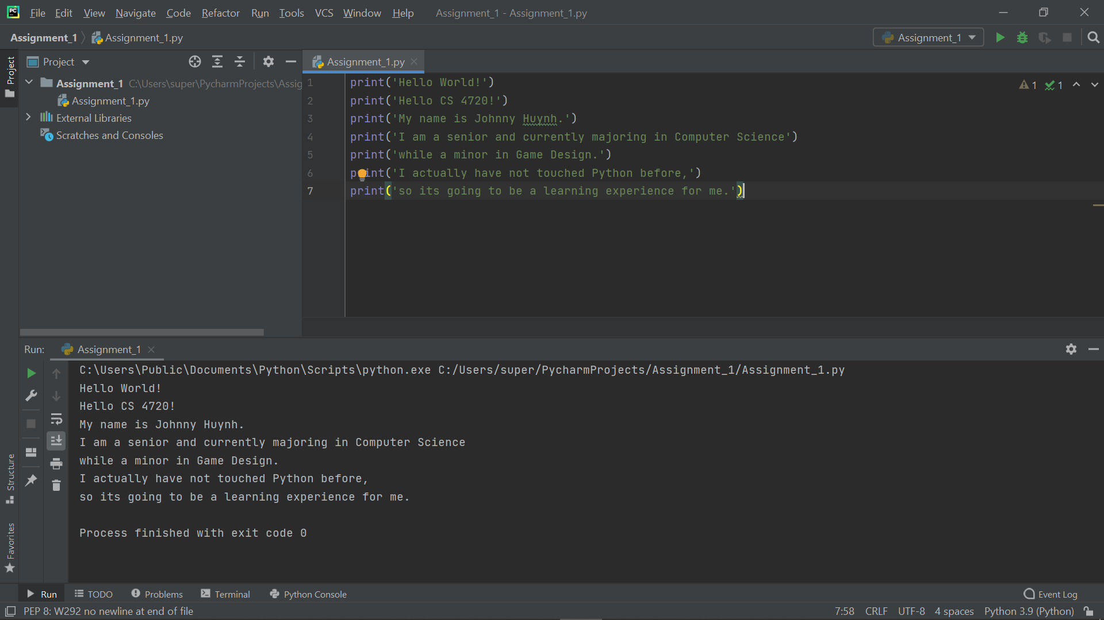

I simply followed what was instructed and provided the information needed.

CSS:

It was straightforward as I used directly in my code for the html, though a common CSS was shared among each section as shown with the files provided in the upload as a way to maintain tabs with each page as shown:

**body {**

**font-family: times-new-roman;**

**margin: 0;**

**}**

**/* Style the header */**

**.header1 {**

**padding: 80px;**

**text-align: center;**

**background: #C82121;**

**color: white;**

**}**

**/* Increase the font size of the h1 element */**

**.header1 h1 {**

**font-size: 50px;**

**}**

**ul {**

**list-style-type: none;**

**margin: 0;**

**padding: 0;**

**overflow: hidden;**

**background-color: #333;**

**}**

**li {**

**float: left;**

**border-right:1px solid #bbb;**

**}**

**li:last-child {**

**border-right: none;**

**}**

**li a {**

**display: block;**

**color: white;**

**text-align: center;**

**padding: 14px 16px;**

**text-decoration: none;**

**}**

**li a:hover:not(.active) {**

**background-color: #111;**

**}**

**.active {**

**background-color: #4CAF50;**

**}**

**/* Style the header */**

**.header2 {**

**padding: 110px;**

**text-align: Center;**

**background: #FFFFFF;**

**color: Black;**

**}**

**/* Increase the font size of the h1 element */**

**.header2 h1 {**

**font-size: 100px;**

**}**